 | Filing Reference : |  | GG/COMS/TS.2/4
 | Document Title : |  | Use-Case Realization Report (Analysis)  Logout
 | Version : |  | 1.0
 | Prepared By : |  | Koh Ming Jin
 | Date Created : |  | Monday, Jul 29th, 2011
Approved By :
 |  | Tran Ba Tien |  | Date
 |  | Project Manager |  | 29th Jul 2011
©2011 [Hoang Kim joint stock Company].
The information contained in this document is the property of [Hoang Kim joint stock Company]. The contents must not be reproduced, wholly or in part, for purposes other than for which it has been supplied, without the prior permission of [Hoang Kim joint stock Company], or, if it has been furnished under contract to another party, as expressly authorised under that contract. [Hoang Kim joint stock Company] shall not be liable for any errors or omissions.

Revision History
Date | Version | Description | Author
29/Jul/2011 | 1.0 | Initial Document | Koh Ming Jin

Table of Contents
1. Brief Description 4
2. Flow of Events 4
2.1 Standard Flow 4
2.2 Exception 4
3. Interaction Diagrams 4
3.1 Collaboration Diagram for System Logout 4
4. Participating Objects 5
4.1 Main Page 5
4.2 Main Controller 5
4.3 Security Controller 5
5. Class Diagrams 5
5.1 Domain Class Diagram: View Logout 5
6. Derived Requirements 5

Use-Case Realization Report
View Logout

Brief Description
This use case enables an employee to log out of the system.

Flow of Events
The standard flow of events for this use case and any exceptions are described in the following subsections. See section 3.1 for an overview of the participating Actors and Domain Objects.

Standard Flow
The flow of events is described as follows:

- The use case starts when an employee selects the Logout option on the Main Page.
- The Main Page will call the logout operation of MainController.
- The MainController will call the logout operation of SecurityController to destroy the user session using the operation destroySession.
- The SSecurityController will return the status back and the MainPage will refresh and show the login option.
- The use case terminates.

Exception
- NIL

Interaction Diagrams

Collaboration Diagram for System Logout
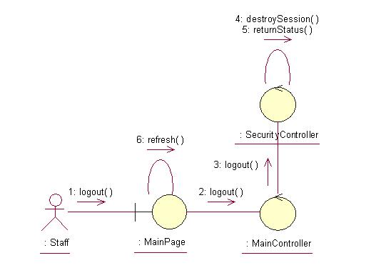

Participating Objects

Main Page
This object renders the contents to allow actors to logout into the system. All actors use this object.

Main Controller
This object acts as the middleman between Main Page and the Security Controller. It will translate interactions with the view into actions to be performed by the Security Controller.

Security Controller
This object acts as the middleman between Main Pages and the Employee and Role objects. It will translate interactions with the view into actions to be performed by the Employee and Role objects.

Class Diagrams

Domain Class Diagram: View Logout
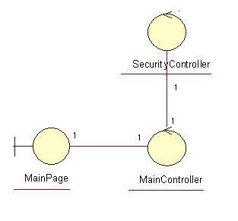

Derived Requirements
The PC keyboard and mouse will be used to logout into the system (if any) and view all the system responses.

